//Program 01 with function

#include<iostream>

using namespace std;

void AllinOne(int x, int y){

    cout << "Sum of Numbers is: " << x + y;

    cout << "\nSub of Numbers is: " << x - y;

    cout << "\nMulti of Numbers is: " << x * y;

    cout << "\nDiv of Numbers is: " << x / y;

}

int main(){

    //Two Numbers sum, sub, mul, div

    // with one function

    int a,b;

    cin >> a >> b;

    AllinOne(a,b);

}

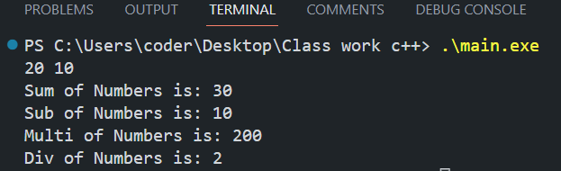

//////////////////Two//////////////////////

//Two Fractional Numbers sum, sub, mul, div

//with one function

#include<iostream>

using namespace std;

void AllinOne(double x, double y){

    cout << "Sum of Numbers is: " << x + y;

    cout << "\nSub of Numbers is: " << x - y;

    cout << "\nMulti of Numbers is: " << x * y;

    cout << "\nDiv of Numbers is: " << x / y;

}

int main(){

    double a,b;

    cin >> a >> b;

    AllinOne(a,b);

}

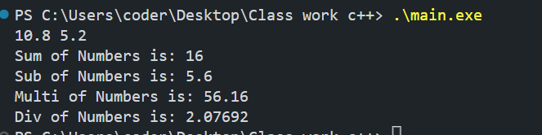

//////////////////Three//////////////////////

//Return type Boolean function

#include<iostream>

using namespace std;

bool TrueFlase(int x){

        if(x == 0){

            return false;

        }else if(x == 1){

            return true;

        }else{

              return false;

        }

}

int main(){

  int x;

  cout << "Please Enter 0 or 1\n";

  cin >> x;

  bool output = TrueFlase(x);

  cout << boolalpha << "You always tell " << output;

}

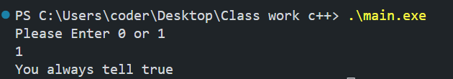

////////////////// Four //////////////////////

//Two Fractional BooleanAdd, subtract, multiply,

//and divide by determine symbols

#include<iostream>

using namespace std;

double calFrac(int x, double y, double z){

  if(x == 1){

    return y+z;

  }else if(x == 2){

    return y-z;

  }else if (x == 3){

    return y*z;

  }else{

    return y/z;

  }

}

int main() {

  int x;

  double y,z;

  string ch = "a";

  cout << "Press (+) for 1: ";

  cout << "\nPress (-) for 2: ";

  cout << "\nPress (x) for 3: ";

  cout << "\nPress (/) for 4: \n";

  cout << "\nPlease Select an Option: ";

  cin >> x;

  while (x < 1 || 4 < x)

  {

    cout << "Wrong! Please select Correct Option: ";

    cin >> x;

  }

  if (x == 1)

  {

    ch = "+ ";

  }else if (x == 2){

    ch = "- ";

  }else if (x == 3){

    ch = "x ";

  }else{

    ch = "/ ";

  }

  cout << "  ";

  cin >> y;

  cout << ch ;

  cin >> z;

  cout << "----------------\n";

  cout << "  ";

  double result = calFrac(x,y,z);

  cout << result;

}

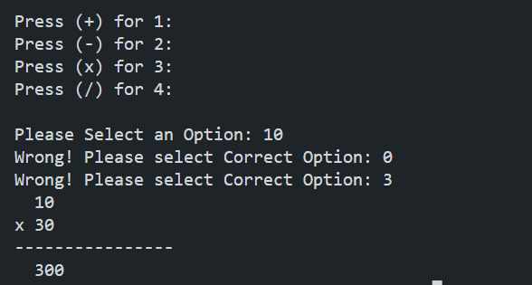

//////////////////Six////////////////////

//Calculate number with recursive function

#include<iostream>

using namespace std;

int calculte(int x, int y, int z){

    if(x == 1){

        return y + z;

    }else if(x == 2){

        return y - z;

    }else if(x == 3){

        return y * z;

    }else if(x == 4){

        return y / z;

    }else{

        cout << "Please Select Correct Option" << endl;

        cout << "Enter 1 for(+): ";

        cout << "\nEnter 2 for(-): ";

        cout << "\nEnter 3 for(x): ";

        cout << "\nEnter 4 for(/): ";

        cin >>  x >> y >> z;

        return calculte(x,y,z);

    }

}

int main(){

    int x,y,z;

    cout << "Enter 1 for(+): ";

    cout << "\nEnter 2 for(-): ";

    cout << "\nEnter 3 for(x): ";

    cout << "\nEnter 4 for(/): ";

    cin >>  x >> y >> z;

    int result = calculte(x, y, z);

    cout << "Result is: " << result << "\n";

}

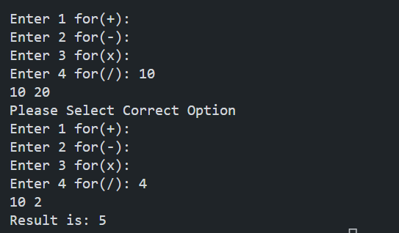

//////////////////Six////////////////////

//Multiply and Increment

#include<iostream>

using namespace std;

int multiply(int x, int y){

    cout << "Before Increment in Function x is:" << x << ", y is:" << y << endl;

    int result = ++x * ++y;

    cout << "After Increment in Function x is:" << x << ", y is:" << y << endl;

    return result;

}

int main(){

    int x = 10;

    int y = 5;

    cout << "Before Increment in function Outside of Funtion x is:" << x << ", y is:" << y << endl;

    int result = multiply(x, y);

    cout << "After Increment in function Outside of Funtion x is:" << x << ", y is:" << y << endl;

}

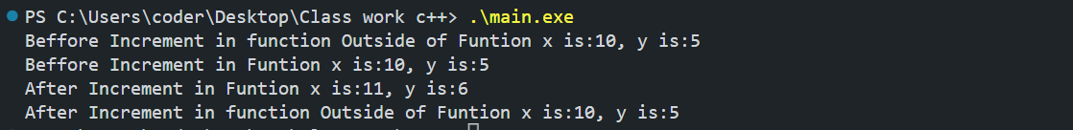

////////////SEVEN/////////////

#include<iostream>

using namespace std;

// Function declaration

int max(int x, int y);

int min(int x, int y);

//You can do this here also

int add(int , int );

int main(){

    int x, y;

    cout << "Please Enter Two Number: ";

    cin >> x >> y;

    cout << "Maximum Number: " << max(x, y) << endl;

    cout << "Minimum Number: " << min(x, y) << endl;

    cout << "Summation of Number: " << add(x, y);

}

//Function Definition

//Find Maximum

int max(int x, int y){

    if(x < y){

        return y;

    }else{

        return x;

        }

};

//Find Minimum

int min(int x, int y){

     if(x > y){

        return y;

    }else{

        return x;

        }

};

//Add Number:

int add(int x, int y){

    return x + y;

};

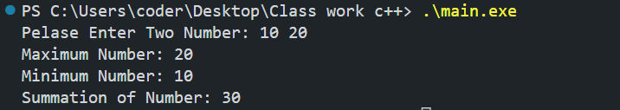

//////////////EIGHT/////////////

//Return String Method

#include<iostream>

using namespace std;

string wishMe(){

    return "Good Luck";

}

int main(){

    cout << wishMe() << endl;

}



//////////////NINE/////////////

//Receive to String and add them

#include<iostream>

using namespace std;

string AddtwoString(string x, string y){

    return x + y;

}

int main(){

   string x = "Hello, ";

   string y = "what's up?";

   cout << AddtwoString(x, y) << endl;

}



//////////////TEN/////////////

//First Letter and Last of Your Name

#include<iostream>

#include <cctype>

using namespace std;

string findFirstLastLetter(string x){

    int len = x.length();

    string s(1, x[0]);

    string s2(1, x[len - 1]);

    string res = "First Letter of your name is: " + s + "\nLast Letter of your name is: " + s2;

    return res;

}

int main(){

    string fullName;

    cout << "Please enter your name: ";

    cin >> fullName;

    cout << endl;

    cout << findFirstLastLetter(fullName) << endl;

}

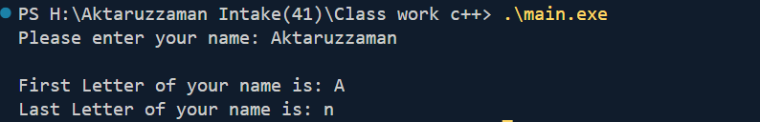

//////////////////ELEVEN////////////////////

//REceive an Array and Sum all element

#include<iostream>

using namespace std;

int addArray(int arr[], size_t len){

    int sum = 0;

    for (size_t i = 0; i < len; i++)

    {

        sum += arr[i];

    }

    return sum;

}

int main(){

    int arr[8] = {1,2,3,4,5,5,4,32};

    int res = addArray(arr,sizeof(arr)/sizeof(arr[0]));

    cout << "Sum of ALl Array Elments is: " << res << endl;

}

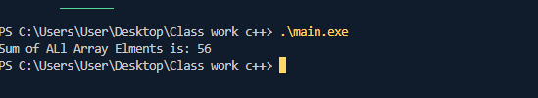

////////////////////////TWELEVE///////////////////////

//////////////////REVERSE AN ARRAY////////////////////

#include<iostream>

using namespace std;

void addArray(int arr[], size_t len){

    int sum = 0;

    int *p = &arr[len-1];

    for (size_t i = 0; i < len; i++)

    {

       cout << *p-- << " ";

    }

}

int main(){

    int arr[8] = {1,2,3,4,5,5,4,32};

    addArray(arr,sizeof(arr)/sizeof(arr[0]));

}

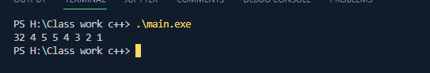

////////////////////////THIRTEEN//////////////////////

//////////////////REVERSE AN STRING////////////////////

#include<iostream>

using namespace std;

string reverse_String(string str, int len){

    string rev;

    for(int i = len; i >= 0; i--){

        rev += str[i];

    }

    return rev;

}

int main(){

    string str;

    cout << "Enter a string: ";

    getline(cin,str);

    int len = str.length()-1;

    string rev_string = reverse_String(str, len);

    cout << rev_string << endl;

}

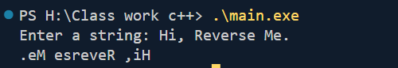

////////////////////////FOURTEEN///////////////////////

//////////////////MAKE POWER FUNTINON//////////////////

#include<iostream>

using namespace std;

size_t Power(int base, int power){

    size_t res = 1;

    if(power == 0){

        return 1;

    }else{

       for(int i = 0; i < power; i++){

        res *= base;

       }

       return res;

    }

}

int main(){

    int base, power;

    cout << "Please enter a base and power this format: Power(base, power): ";

    cin >> base >> power;

    size_t powRest = Power(base, power);

    cout << "\nBase: " << base << "\nPower: " << power << "\nResult: " << powRest << endl;

}

